**The Evolution of the Banking System in the United States**

**Early Innovations (Before 1960s)**

**Telegraph and Wire Transfer**

* **Introduction**: The telegraph, invented in the 19th century, revolutionized long-distance communication and laid the groundwork for wire transfers.
* **Benefits**: Enabled faster and more secure financial transactions between distant locations.
* **Disadvantages**: Limited to institutions with access to telegraph infrastructure and required manual intervention.

**Check Clearinghouses**

* **Introduction**: Check clearinghouses were established in the mid-19th century to facilitate the settlement of checks between banks.
* **Benefits**: Standardized the process of exchanging checks, reduced settlement time, and improved efficiency.
* **Disadvantages**: Relied on physical transportation of checks, which could be slow and prone to errors.

**Mainframe Computers (1960s-1970s)**

**Introduction of Mainframe Computers**

* **Introduction**: Banks began using mainframe computers to automate back-office operations, such as account management and transaction processing.
* **Benefits**: Improved data processing capabilities, increased efficiency, and reduced operational costs.
* **Disadvantages**: High initial costs, required specialized knowledge for operation, and limited flexibility.

**Automated Clearing House (ACH)**

* **Introduction**: The ACH network was developed to facilitate electronic payments and direct deposits.
* **Benefits**: Reduced reliance on paper checks, improved transaction speed, and increased convenience for consumers.
* **Disadvantages**: Initial setup costs and required coordination between participating financial institutions.

**ATMs and Online Banking (1980s-1990s)**

**Automated Teller Machines (ATMs)**

* **Introduction**: ATMs became widespread in the 1980s, providing customers with 24/7 access to cash and banking services.
* **Benefits**: Increased convenience, reduced wait times, and expanded access to banking services.
* **Disadvantages**: High installation and maintenance costs, potential security risks, and limited transaction types.

**Debit and Credit Cards**

* **Introduction**: Debit and credit cards gained popularity in the 1980s and 1990s, offering a convenient alternative to cash and checks.
* **Benefits**: Facilitated quick and secure transactions, reduced the need for carrying cash, and offered consumer protections.
* **Disadvantages**: Potential for fraud and identity theft, fees for merchants and consumers, and risk of debt accumulation.

**Online Banking**

* **Introduction**: The rise of the internet in the 1990s led to the advent of online banking.
* **Benefits**: Allowed customers to access their accounts, perform transactions, and manage finances from home, improving convenience and efficiency.
* **Disadvantages**: Security concerns, required internet access, and potential for technical issues.

**Mobile and Digital Banking (2000s-Present)**

**Mobile Banking**

* **Introduction**: The proliferation of smartphones in the 2000s brought about mobile banking.
* **Benefits**: Enabled customers to conduct banking activities on the go, including transferring funds, depositing checks, and monitoring account activity.
* **Disadvantages**: Security vulnerabilities, dependence on mobile devices and internet access, and potential for technical glitches.

**Digital Payments and Fintech Innovations**

* **Introduction**: The 2010s saw the rise of digital payment platforms such as PayPal, Venmo, and Zelle, along with fintech innovations.
* **Benefits**: Provided new payment options, enhanced convenience, and increased competition in the financial sector.
* **Disadvantages**: Regulatory challenges, security concerns, and potential for market disruption.

**Artificial Intelligence and Machine Learning**

* **Introduction**: Banks began leveraging AI and machine learning for fraud detection, customer service, and personalized financial advice.
* **Benefits**: Improved operational efficiency, enhanced customer experience, and reduced fraud.
* **Disadvantages**: High implementation costs, ethical concerns, and potential for job displacement.

**Open Banking and APIs**

* **Introduction**: Open banking initiatives promoted the use of APIs to enable third-party developers to build new financial services.
* **Benefits**: Increased innovation, more tailored financial products, and improved customer choice.
* **Disadvantages**: Data privacy concerns, regulatory compliance challenges, and potential security risks.

**Future Trends**

**Blockchain and Cryptocurrencies**

* **Introduction**: Blockchain technology and cryptocurrencies are expected to play a significant role in the future of banking.
* **Benefits**: Secure, transparent, and efficient transactions with reduced need for intermediaries.
* **Disadvantages**: Regulatory uncertainty, volatility of cryptocurrencies, and potential for illicit activities.

**Enhanced Security Measures**

* **Introduction**: With the rise of cyber threats, banks are investing in advanced security measures.
* **Benefits**: Improved protection of customer data and reduced risk of fraud.
* **Disadvantages**: High implementation costs and potential for technological arms races with cybercriminals.

**Integration of IoT and Smart Banking**

* **Introduction**: The Internet of Things (IoT) is expected to further integrate with banking services.
* **Benefits**: Seamless transactions and account management through smart devices, improved customer convenience.
* **Disadvantages**: Security vulnerabilities and dependence on technology infrastructure.

**Growth in Online and Mobile Banking Adoption**

* **Online Banking Usage**: As of 2021, approximately 76% of U.S. adults used online banking services.
* **Mobile Banking Usage**: In 2021, about 61% of U.S. adults used mobile banking apps.

**ATM and Branch Statistics**

* **Number of ATMs**: As of 2020, there were over 470,000 ATMs in the United States.
* **Number of Bank Branches**: The number of bank branches has been declining, with approximately 76,000 branches in 2020, down from 83,000 in 2012.

**Digital Payment Transactions**

* **Digital Payments**: Digital payment transactions have been on the rise, with mobile payment volume in the U.S. projected to reach $1.2 trillion by 2023.

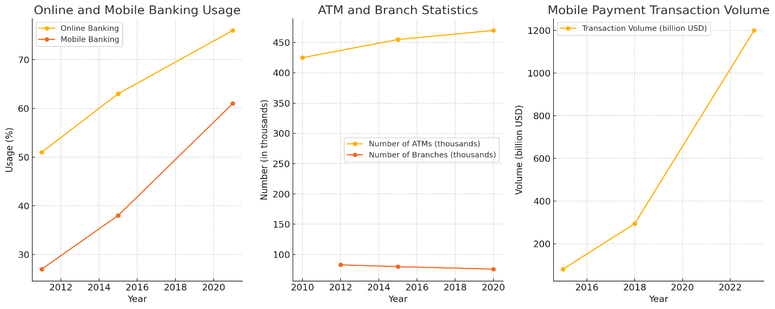

**Banking System Resilience During Economic Crises in the United States**

**Historical Perspective**

**The Great Depression (1929-1939)**

* **Impact**: Over 9,000 banks failed, and unemployment peaked at 25%.
* **Response**: The establishment of the Federal Deposit Insurance Corporation (FDIC) in 1933 to insure deposits and restore trust.

**The Financial Crisis of 2007-2008**

* **Impact**: The collapse of major financial institutions, $700 billion TARP bailout, and a global recession.
* **Response**: Implementation of the Dodd-Frank Act in 2010 to increase regulatory oversight and prevent future crises.

**Key Resilience Indicators**

**Capital Adequacy**

* **Definition**: Banks' ability to absorb losses.
* **Measure**: Tier 1 capital ratio.
* **Data**: Increased from 9.3% in 2008 to 13.7% in 2020.

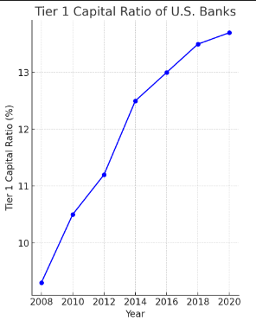

**Liquidity**

* **Definition**: Availability of liquid assets to meet short-term obligations.
* **Measure**: Liquidity Coverage Ratio (LCR).
* **Data**: Introduction of LCR requirement in 2015, with banks consistently maintaining above 100%.

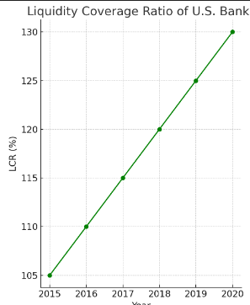

**Stress Testing**

* **Definition**: Evaluation of banks' ability to withstand economic shocks.
* **Measure**: Results of the Federal Reserve's annual stress tests.
* **Data**: Banks passing stress tests since their introduction in 2009.

